**Practical No. 4**

**Aim: To verify 4­variable K­map.**

**Apparatus**: Connection wires, power supply, power project board.

**Theory:**

A map method provides a simple straight procedure for minimizing boolean functions. This method may be regulated either as a pictorial form of a truth or as an extension of the venn­diagram.

The map method, first propose by veitch and slightly modified by Karnaugh. So it also known as the “Veitch diagram” or the “Karnaugh map”.

The map is a diagram made up of squares. Each square represents one min­term. Since any Boolean function can be expressed as a sum of min terms, it follows that a Boolean function is recognized graphically in the map from the area enclosed by those squares whose min­terms are included in the function.

**Procedure:**

1. Solve the problem given by lab instructor with help of basic logic Gates.
2. Find out the proper input and output.
3. Use pin diagram and make proper connection as per requirement.
4. Measure the various output in LED on/off condition with different input condition. Note down the observation table.
5. Compare truth table with observation table and write conclusion.

**Example:**

Minterm: ∑m (0,1,2,4,5,6,8,9,12,13,14)

K-MAP:

**YZ 00 01 11 10**

|  |  |  |  |
| --- | --- | --- | --- |
| **1** | **1** | **0** | **1** |
| **1** | **1** | **0** | **1** |
| **1** | **1** | **0** | **1** |
| **1** | **1** | **0** | **0** |

**WX 00**

**01**

**11**

**10**

Reduced Equation:

**F=Y’+W’Z’+XZ’**

TRUTH TABLE:

**ORIGINAL EQUATION:**

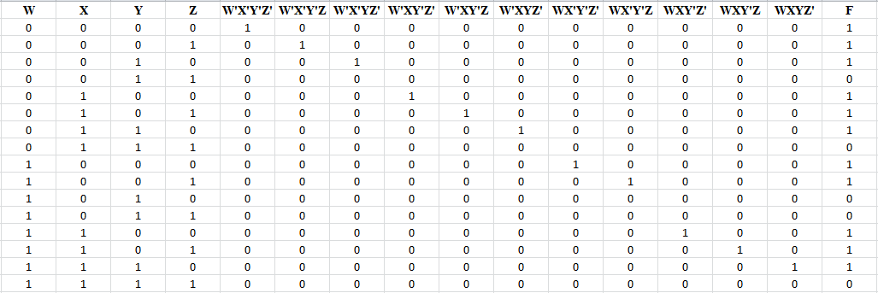

**REDUCED FORM OF EQUATION:**

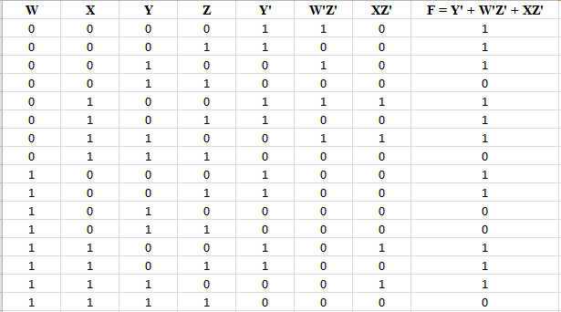

**Circuit Design:**

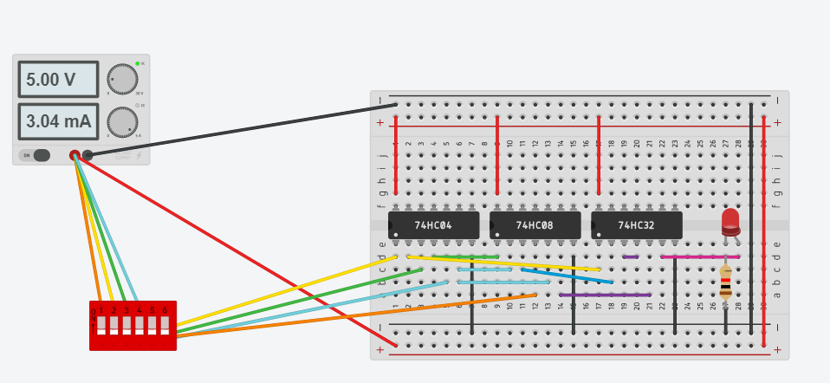

**FOR X=0,Y=0,Z=0,W=0**

**CONCLUSION:**

By performing the above practical, we came to know about the importance of K-Map as it can save lot of hardware and also makes the circuit more faster and effiecient